Unit 3 test
Vocabulary
Vocabulary
1 Look and tick ().
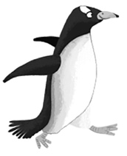 | 1 A ☐ elephant  B ☐ penguin
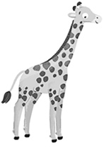 | 2 A ☐ hippo  B ☐ giraffe
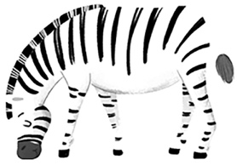 | 3 A ☐ zebra  B ☐ tiger
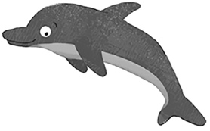 | 4 A ☐ dolphin  B ☐ monkey
/ 4
2 Look, read and circle.
 | 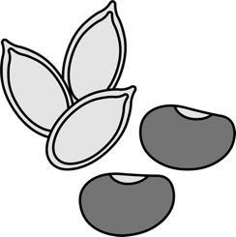 |  |  | 1 nuts / grass  2 seeds / leaves  3 insects / meat  4 seeds / nuts  5 insects / grass  6 leaves / meat
1 | 2 | 3
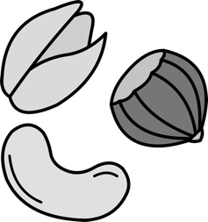 | 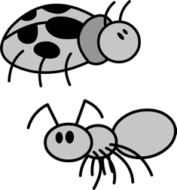 | 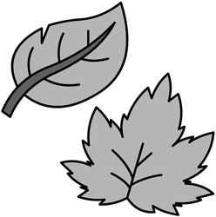
4 | 5 | 6
/ 6

Grammar
3 Look, read and circle.
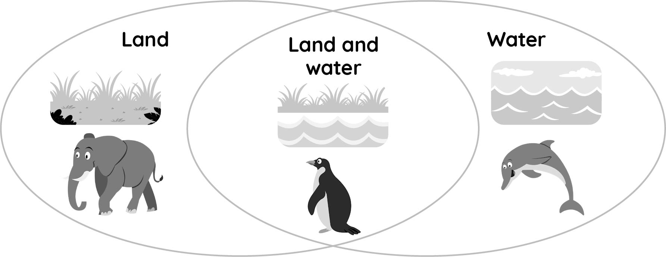
1 Dolphins live in water. True / False
2 Do penguins live on land and in water? Yes, they do. / No, they don’t.
3 Elephants live in water. True / False
4 Do dolphins live on land? Yes, they do, / No, they don’t.
/ 4
4 Look, read and circle. What do the animals eat?
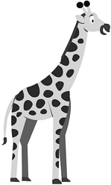 |  | 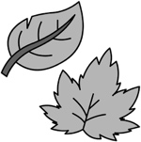 |  |  | 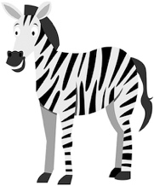 |  |  |  |  | 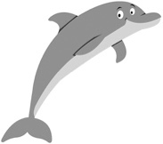 |  | 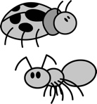 |  | 
1 They eat / don’t eat leaves. |  |  |  |  | 2 They eat / don’t eat meat. |  |  |  |  | 3 They eat / don’t eat  insects.
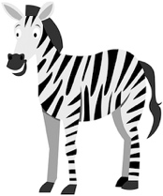 |  |  |  |  | 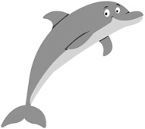 | 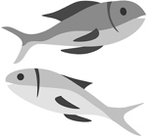 |  |  |  | 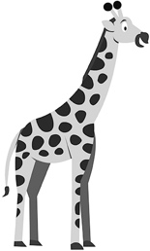 |  |  | 
4 They eat / don’t eat grass. |  |  |  |  | 5 They eat / don’t eat  fish. |  |  |  |  | 6 They eat / don’t eat  fish.
/ 6
Reading
5 Read and tick ().
Wild animals in Canada by Olivia
Canada is a beautiful country with lots of wild animals. Foxes live on land. They are red. They eat meat. They can run and they can jump. Canada has got lots of snakes, too.
They are my favourite animal. They have long bodies, but they haven’t got legs.
They eat insects, but they don’t eat leaves. They live on land and in water.
You can see lots of colourful fish in Canada. They live in water – in the Atlantic Ocean. They’re amazing!
1 Canada …
A ☐ is beautiful. B ☐ isn’t beautiful.
2 Canada …
A ☐ has got animals. B ☐ hasn’t got animals.
3 Foxes …
A ☐ like meat. B ☐ don’t like meat.
4 Snakes have got long …
A ☐ legs. B ☐ bodies.
5 Snakes eat …
A ☐ leaves. B ☐ insects.
/ 5
Writing
6 Read and write.
can swim can’t fly don’t eat seeds don’t live in water have got tails
1 Zebras live on land, but they .
2 Snakes can’t jump, but they .
3 Foxes haven’t got wings, but they .
4 Tigers eat meat, but they .
5 Fish can swim, but they .
/ 5

Listening
7  3 Listen and write the letter.
 |  | 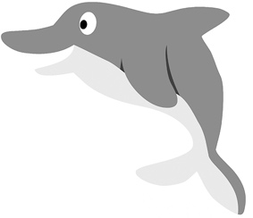 |  | 1  2  3  4  5
A | B | C
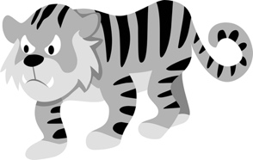 | 
D | E
/ 5
Speaking
8 Look and answer.
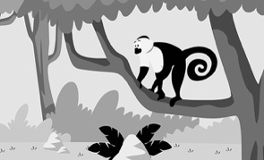 | 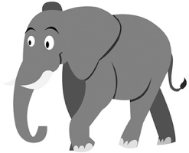 | 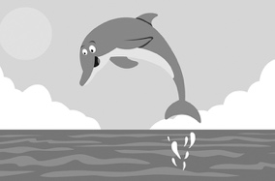 |  | 1 Do monkeys live in your country?  2 Do elephants live in your country?  3 Do dolphins live in your country?  4 Do zebras live in your country?  5 Do giraffes live in your country?
1 | 2 | 3
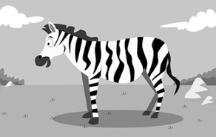 | 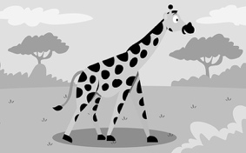
4 | 5
/ 5
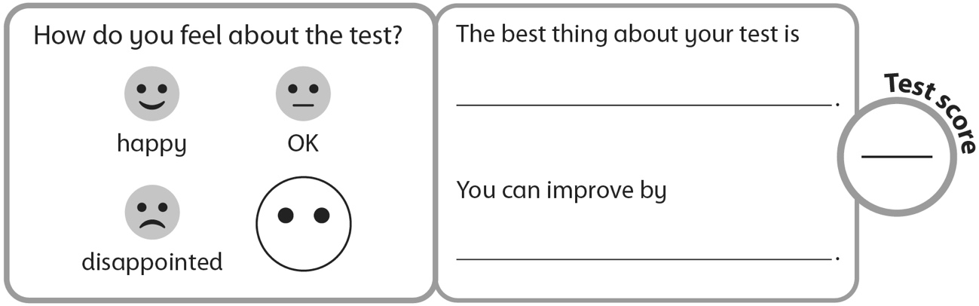
40

